CISC 3000-001
Web Programming

Team Project Project
College Meal Reservation System:
Improvement

Team05

Pair 13
DC325629, Lam Ka Wai
DC325315, Chao Wen Jie
Pair 03
DC325683, Lok Wang Fong
DC228400, Wang Yu Feng
Pair 19
DC328563, Lang Si Yu
DC325523, Lam Cheng Io

Submission Date: May 10, 2026

TABLE OF CONTENT
1. Project Abstract 2
2. Project Context - Full-Stack Web Applications with RWD and Deployed URL 2
3. Project Goals 2
4. Project Services and Data Requirements 3
5. Project Tasks and Tools 5
6.Project Challenges 7
7.Project Deliverables 7
8.Project Division of Work among team members 8
9.Project Contributions from individual team members 8
10.Project Criteria of Success 9
11.Evaluation Rubric 10
12.Project Learning - Individual + Team 11
13.Project Test Case(s) for Functional Requirements 11
14.Project Demo Walkthrough (Screen Shots) 17
15.Project Related References 17

1. Project Abstract
The College Meal Reservation System is a full-stack web application designed to address the significant issue of long waiting times in university canteens. By allowing students to pre-order meals online and select a specific pickup time slot, the system aims to reduce average queue times by an estimated 50%, optimizing both the student experience and canteen operations. This capstone project integrates responsive frontend design (HTML/CSS/JS) with a PHP backend and a MySQL database to create a complete e-commerce solution. Core features include user account management with email verification and password reset, a persistent shopping cart, meal browsing with search and filter capabilities, and a secure checkout process with order history. The project demonstrates the application of technology to solve a real-world campus logistics problem, showcasing a portfolio-ready, full-stack web application. The system is deployed to a public URL, ensuring accessibility without local setup, and includes data visualization of peak reservation times and popular meal categories for operational insights.

2. Project Context - Full-Stack Web Applications with RWD and Deployed URL
This project serves as a capstone experience, integrating responsive frontend design (HTML/PHP/CSS/JS), server-side scripting with PHP, and a relational database (MySQL) to build a dynamic, data-driven website. It implements essential e-commerce features (shopping cart, order history) and user account management (email verification, password reset), representing a complete full-stack web application built on the PHP and MySQL stack. Responsive Web Design (RWD) is achieved through native CSS media queries, ensuring seamless usability on mobile, tablet, and desktop devices. The system is deployed to a public URL via ngrok, making it accessible without any local setup and allowing for real-world user testing and demonstration.
Deployed Public URL:Home | Crispy College Meals

3. Project Goals
Reduce average queue time at residential college canteens by 50% through online pre-ordering and scheduled pickup slots.

Provide a complete e-commerce flow: user registration, email verification, login, meal browsing, persistent shopping cart, checkout, and order history.

Ensure a fully responsive design that functions correctly on mobile, tablet, and desktop screen sizes.

Implement secure authentication mechanisms including password hashing (bcrypt), email verification tokens, and password reset tokens.

Deploy a publicly accessible, fully functional beta system for user testing and demonstration.

4. Project Services and Data Requirements
Services (User-Facing):
- Register an account and verify email address.
- Login and reset forgotten password
- Browse whole meal list with category filtering and keyword search.
- Receive three random meal recommendations on the homepage.
- Add/remove items and update quantities in a persistent shopping cart.
- Choose a pickup time slot and place an order.
- View order history and order details with keyword search.

Data Requirements:
Performance: Capable of handling 10+ concurrent bookings without data corruption or race conditions – PHP business logic with MySQL transactions (or simple capacity checks) ensures data integrity.
Usability: A streamlined booking process that takes a user no more than 3 steps from meal selection to confirmation, supported by fast PHP backend responses.
Responsiveness: Perfect layout across mobile, tablet, and desktop screens, with all dynamic content served by PHP scripts.

Deployment Requirement (PHP environment):
The system must be deployed to a public URL (Render, Railway, Vercel, or equivalent) that supports PHP and MySQL.
The URL must be accessible without local setup – a standard PHP hosting environment (e.g., with Apache/Nginx).
Screenshots of the deployed site (showing PHP‑generated pages) must be included in the final report.

Authentication & Security (PHP‑centric):
Passwords hashed using password_hash() (bcrypt).
Email verification required before login (token valid 24h).
Password reset with time‑limited token (1h).
All inputs validated server‑side with PHP filters and prepared statements (PDO).
Shopping cart stored in $_SESSION['cart'] (not database).
Order history retrieved via PHP queries.
Responsive design on every page.

Logic Constraints:
Slot capacity checked before order insertion; if full, order rejected.

Shopping Cart (session‑based):
Frontend: Display cart items, update quantities, remove items, proceed to checkout.
Backend: Cart data stored in $_SESSION['cart'] (no database persistence).
Cart‑to‑order conversion: On checkout, PHP reads session cart, creates order record, inserts order_items, then clears session cart.
Email Verification Flow (PHP implementation):
User signs up → PHP generates verification token (bin2hex(random_bytes(32))) with expiration (24h).
Token stored in MySQL.
PHPMailer sends email with link: /verify.php?token=xxx (link uses dynamic site_url).
User clicks link → PHP validates token → sets email_verified = 1.
Login only allowed if email_verified = 1.
Password Reset Flow (PHP implementation):
User requests reset → PHP generates reset token (1h expiry) and stores in MySQL.
PHPMailer sends email with link: /reset-password.php?token=xxx.
User sets new password → PHP updates password hash and clears token.
Deployment:
Public URL provided via ngrok (or alternative).
The URL is accessible without local setup.

5. Project Tasks and Tools
Tech Stack:
Frontend: HTML5, CSS3 (custom responsive design), JavaScript (ES6), Fetch/AJAX.
Backend: PHP (with PDO for database interactions), session management, PHPMailer for email services.
Database: MySQL.
Deployment: ngrok for a temporary public URL.
Tools: Git for version control, VS Code/Eclipse as IDEs.

Day | Task Description | Deliverable
Day 1 | Requirements & Database Design: Define user roles, ER diagram, create SQL schema (users, meals, pickup_slots, orders, order_items). | ER diagram, SQL schema script
Day 2 | Frontend & Backend Setup: Build responsive PHP pages: register.php, login.php, forgot-password.php, reset-password.php, index.php (meal listing), checkout.php, orders.php. Implement interactive cart (session‑based). | Interactive PHP/HTML/CSS/JS prototype
Day 3 | Backend Development: Implement user registration (hashed password, verification token, PHPMailer email), email verification (verify.php), login (session‑based), password reset request & confirmation, meal data fetch, cart CRUD (session), order creation (slot capacity check, cart‑to‑order conversion). | Backend PHP scripts + email service
Day 4 | Integration & Testing: Connect frontend to backend, test full flows: signup → verify email → login → add to cart → checkout → view order history → password reset. Fix bugs, test slot capacity. | Fully functional beta system
Day 5 | Deployment & Documentation: Deploy to public URL via ngrok. Prepare final report, user manual, self‑assessment checklist, user testing summary, and screenshots. | Live URL, final report

6.Project Challenges

Security: Generating secure, time-limited tokens for email verification and password reset, preventing replay attacks, and protecting against SQL injection (using PDO prepared statements) and XSS/CSRF.

Concurrency Control: Enforcing pickup slot capacity to prevent overbooking. Implementing PHP business logic with MySQL transactions to check remaining capacity before inserting an order, ensuring data integrity under concurrent requests.

Responsive Design: Adapting complex, data-heavy interfaces like the shopping cart and order history pages to remain usable and visually coherent on small mobile screens.

Cart Persistence: Maintaining the shopping cart across user logins and logouts by storing cart data in the database (MySQL) associated with the user ID.

7.Project Deliverables
Deliverable | Status
SQL schema script | Completed
Fully responsive PHP pages | Completed
Backend PHP APIs + email service (PHPMailer) | Completed
Persistent shopping cart (MySQL) & order history | Completed
Slot capacity enforcement logic | In progress
Public deployment URL (live demo) | Completed
Final report, user manual, self-assessment checklist | Planned
Data visualizations (peak times, popular categories) | Planned
Screencast demonstration | In progress

8.Project Division of Work among team members
Member | Responsibility
Lam Cheng Io | Registration, login, email verification, password reset
Lang Si Yu | Meal listing, category filtering, keyword search
Chao Wen Jie | Add/remove items, update quantity, cart page
Wang Yu Feng | Checkout, order history, order details
Lok Wang Fong | Global styling, navigation, responsive layout, module integration
Lam Ka Wai | Deployment, testing, documentation, demo preparation

9.Project Contributions from individual team members

Lam Cheng Io, Ellie: Implemented PHP user authentication with token-based email verification & password reset using PHPMailer. Secured password storage using password_hash().

Lang Si Yu, Rachel: Built dynamic meal listing, search/filter PHP endpoints, and integrated with the frontend using Fetch/AJAX.

Chao Wen Jie, John: Developed persistent shopping cart functionality (add/remove, quantity update) with MySQL storage and AJAX-based UI updates.

Wang Yu Feng, Kiran: Implemented checkout logic, cart-to-order conversion, order history retrieval, and time-slot capacity validation with PHP.

Lok Wang Fong, William: Created the entire responsive UI with custom CSS media queries, designed the navigation structure, and integrated all frontend modules.

Lam Ka Wai, Michael: Deployed the system to a public URL via ngrok, conducted end-to-end testing, wrote the documentation (proposal and project), and prepared the demo.

10.Project Criteria of Success

Functional Excellence (PHP-driven):
Users can sign up → PHP sends verification email → verify email → log in (PHP session management) → use search to find meals (PHP search endpoint) → add items to shopping cart (persistent via PHP + MySQL) → choose pickup slot → checkout (PHP cart-to-order conversion) → view order history (PHP retrieves from database).
Password reset works via PHP token generation, email sending, and validation.
Cart reflects real-time changes (JavaScript and PHP API) and survives logout/login because PHP restores cart from database on each session.

Non-Functional Quality:
Performance: Capable of handling 10+ concurrent bookings without data corruption or race conditions – PHP business logic with MySQL transactions (or simple capacity checks) ensures data integrity.
Usability: A streamlined booking process that takes a user no more than 3 steps from meal selection to confirmation, supported by fast PHP backend responses.
Responsiveness: Perfect layout across mobile, tablet, and desktop screens, with all dynamic content served by PHP scripts.

Deployment Requirement (PHP environment):
The system must be deployed to a public URL (Render, Railway, Vercel, or equivalent) that supports PHP and MySQL.
The URL must be accessible without local setup – a standard PHP hosting environment (e.g., with Apache/Nginx).
Screenshots of the deployed site (showing PHP-generated pages) must be included in the final report.

11.Evaluation Rubric
The project performance will be measured against the following dimensions:
Functional Completeness (40%):
All main flows (signup, email verification via PHP mailer, login with PHP session, password reset with PHP token handling, search using PHP endpoints, cart operations via PHP API, order history retrieved by PHP) operate without critical bugs. Shopping cart persists in PHP/MySQL and converts to history correctly through PHP cart‑to‑order logic.

Code Quality (20%):
Clean, modular PHP code with appropriate comments (PHPDoc), security measures (prepared statements in PHP PDO, password hashing with password_hash()), and consistent naming conventions following PSR standards.

User Experience (20%):
Aesthetic design, intuitive navigation, and mobile optimization – with all dynamic content served by PHP scripts and interactive features powered by JavaScript communicating with PHP backends.

Documentation (20%):
A thorough report justifying technical choices (including why PHP was selected for server‑side logic), detailing test results of PHP endpoints and database interactions, and explaining the full‑stack architecture.

Final Deliverable Add‑ons (all backed by PHP):
A self‑assessment checklist based on the project requirements (including all new features – verified through PHP implementation).
Data Visualization: peak reservation times and most searched meal categories – generated by PHP queries from the database and rendered on the frontend.

12.Project Learning - Individual + Team
Individual Learning:
- Lam Cheng Io: Secure user authentication with PHP sessions, token-based email verification, and password reset using PHPMailer.
- Lang Si Yu: Search and filter logic in PHP with MySQL, dynamic meal listing using native HTML/CSS/JS
- Chao Wen Jie: Persistent shopping cart management with PHP/MySQL and AJAX-based quantity updates.
- Wang Yu Feng: Cart-to-order conversion, order history retrieval, and time-slot capacity validation with PHP.
- Lok Wang Fong: Responsive layout using CSS media queries and integration of all frontend/backend modules.
- Lam Ka Wai: PHP/MySQL deployment to a public server (ngrok), end-to-end testing, and technical documentation.

Team Collaboration Takeaways:

- Used Git for branch management and successfully resolved merge conflicts.
- Defined clear API contracts before coding to reduce integration issues.
- Held weekly sync meetings to identify blockers and redistribute tasks.
- Conducted code reviews to catch bugs early and improve overall code quality.
- Collaboratively debugged, especially during the complex cart-order integration phase.

13.Project Test Case(s) for Functional Requirements

Feature | Test Steps | Expected Result | Status
User Registration | 1. Go to register.php.  2. Enter full name, valid email, optional phone (8-15 digits), password (≥6 chars), and confirm.  3. Submit. | User created in users table with email_verified = 0. Verification email sent via PHPMailer. Success message displayed. | Pass
Email Verification | 1. Click the link from the verification email (verify.php?token=...).  2. Token valid and not expired. | email_verified set to 1. Verification token cleared. Success message: “Email verified successfully! You can now log in.” | Pass
Login (Verified User) | 1. Enter verified email and correct password on login.php.  2. Submit. | PHP session created. Redirected to index.php. last_login timestamp updated. | Pass
Login (Unverified Email) | 1. Enter unverified email and correct password.  2. Submit. | Error: “Please verify your email before logging in.” Login denied. | Pass
Password Reset Flow | 1. On forgot-password.php, enter registered email.  2. Click reset link from email (reset-password.php?token=...).  3. Enter new password (≥6 chars) and confirm. | reset_token generated and expires in 1 hour. New password hashed and stored. Tokens cleared. Success message shown. | Pass
Browse Menu by Time | 1. Logged-in user visits menu_by_time.php.  2. Switch between “Breakfast” and “Lunch & Dinner” tabs.  3. Use keyword search or category filter. | Only meals with matching available_time displayed. Filters work correctly. Items from wrong period cannot be added. | Pass
Add to Cart (AJAX) | 1. On any menu page, click “Add to Cart” for a meal available in the current period.  2. Adjust quantity (1-20). | Cart stored in $_SESSION['cart']. Cart sidebar updates instantly without page reload. Cart count badge updates. | Pass
Checkout – Slot Compatibility | 1. Add breakfast-only items to cart.  2. Go to checkout.php, select a pickup date.  3. View available time slots. | Only breakfast slots (07:30-10:30) are enabled. Lunch/dinner slots disabled. Mixed-cart items cause all slots disabled. | Pass
Place Order – Balance Payment | 1. Ensure user balance ≥ order total.  2. Select payment method “Balance”.  3. Choose valid pickup date and slot with capacity.  4. Submit order. | Order created in orders table. order_items populated. User balance reduced by total. Cart cleared. Redirect to order details. | Pass
Order History & Deletion | 1. Logged-in user goes to orders.php.  2. View list of past orders.  3. Click “View details” then “Delete this order”.  4. Confirm deletion. | Order list shows only user’s orders. Search works. Deleted order removed from database (cascade delete). Flash success message. | Pass

14.Project Demo Walkthrough (Screen Shots)
[Figure 1: Registration page with input validation for name, email, phone, and password]
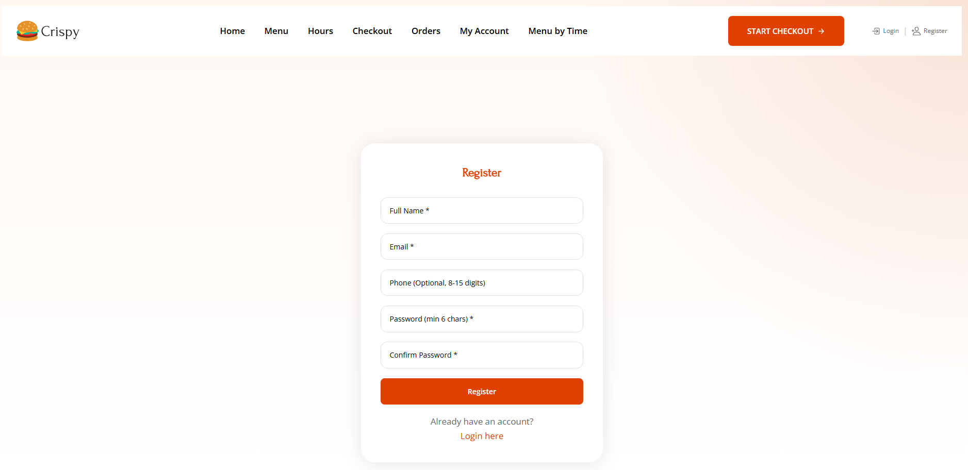
[Figure 2: Email verification message sent via PHPMailer]
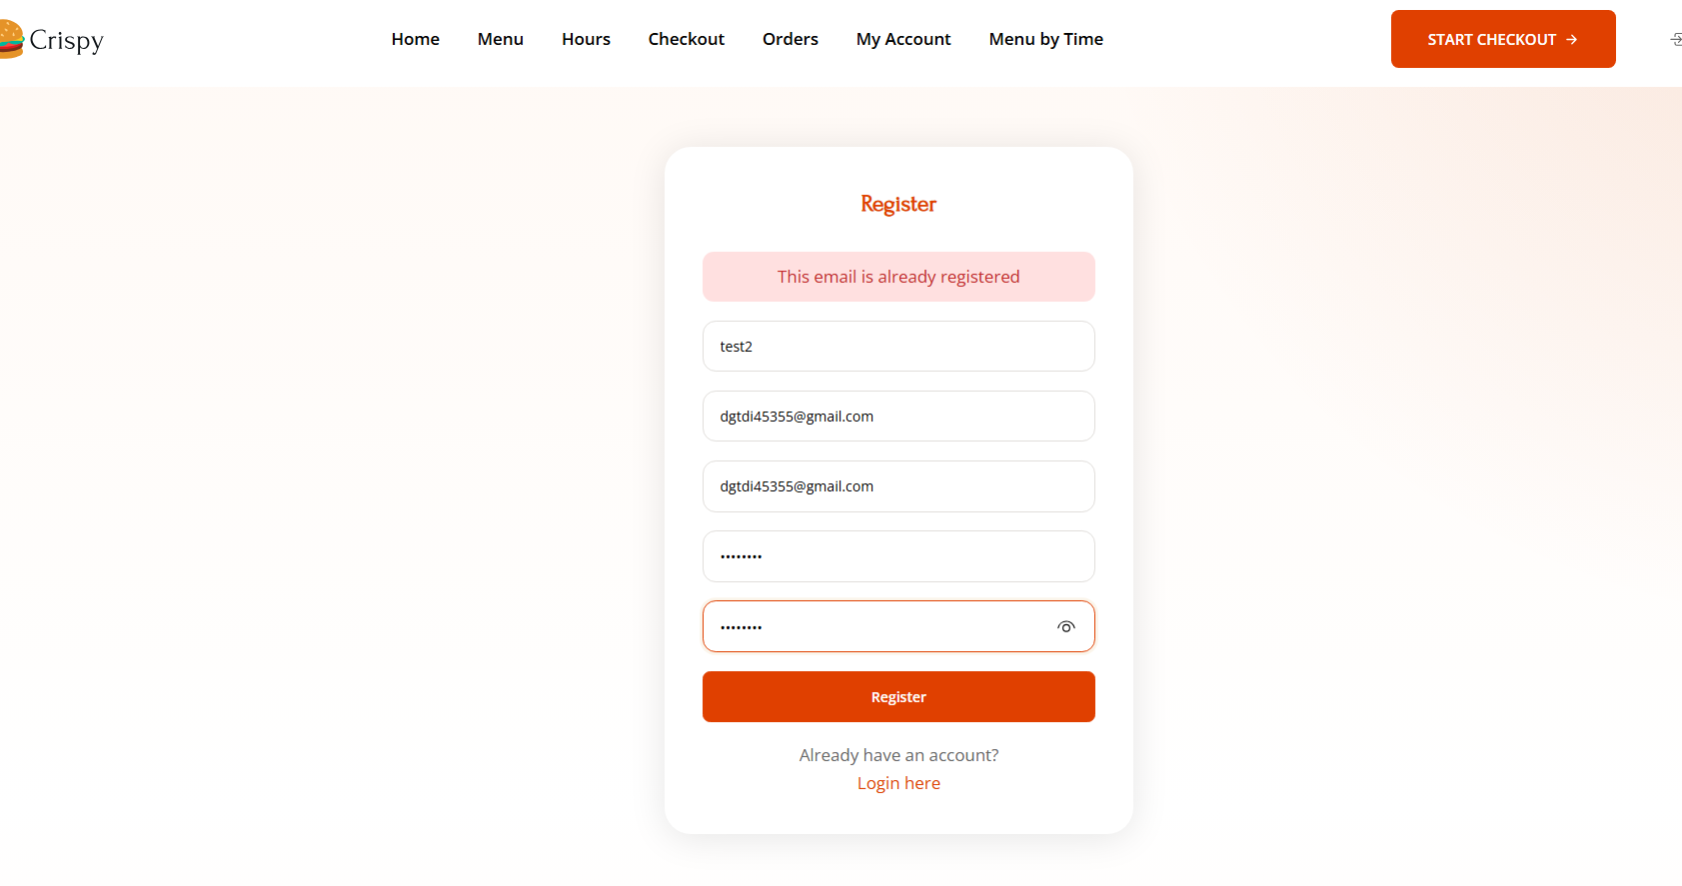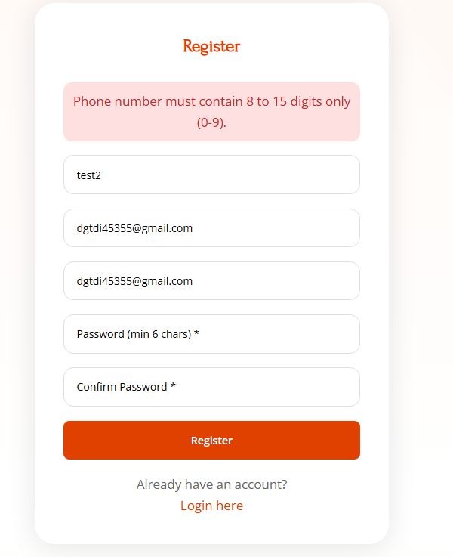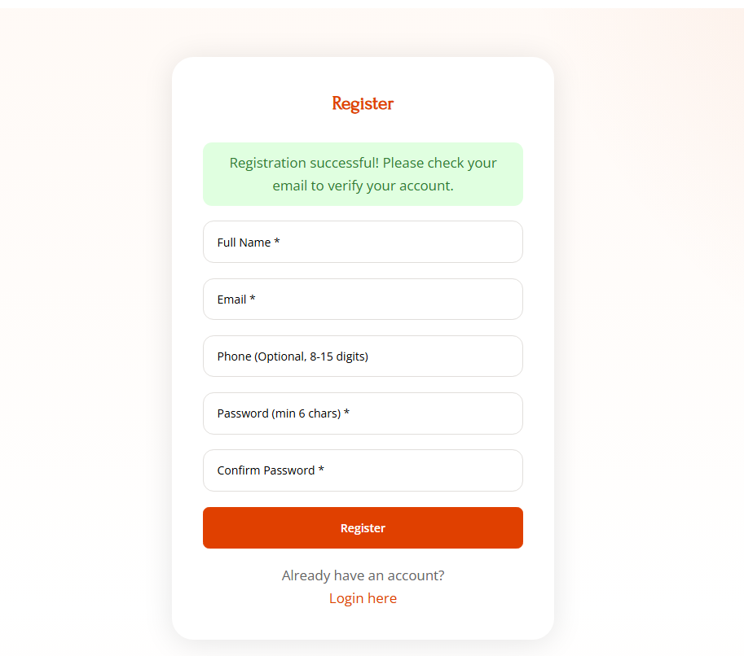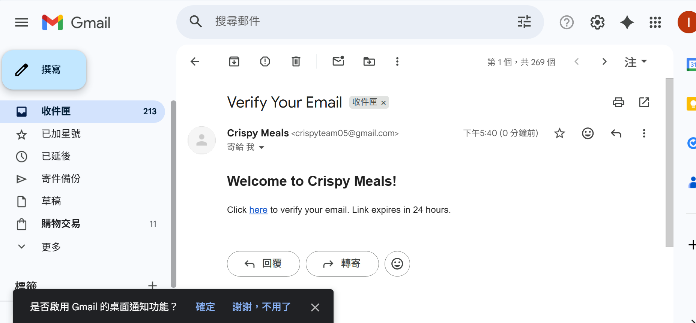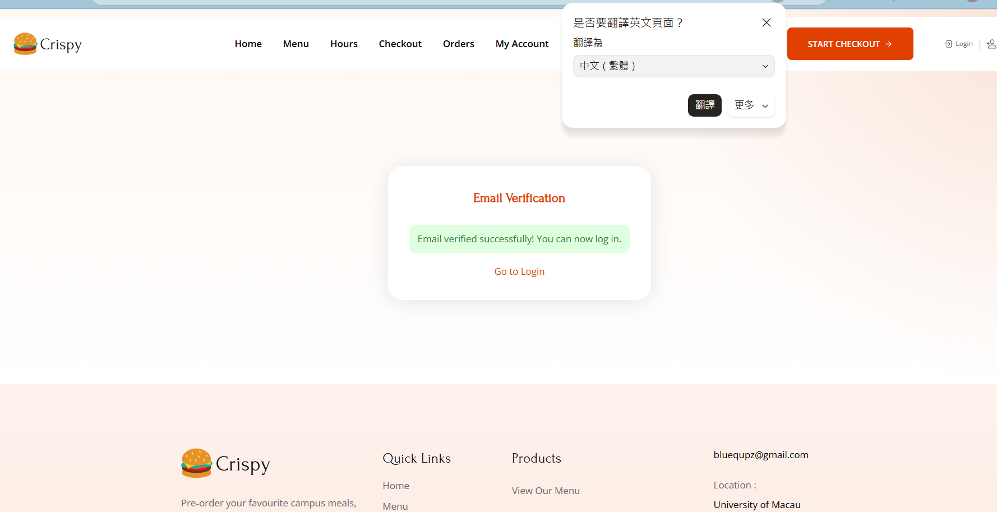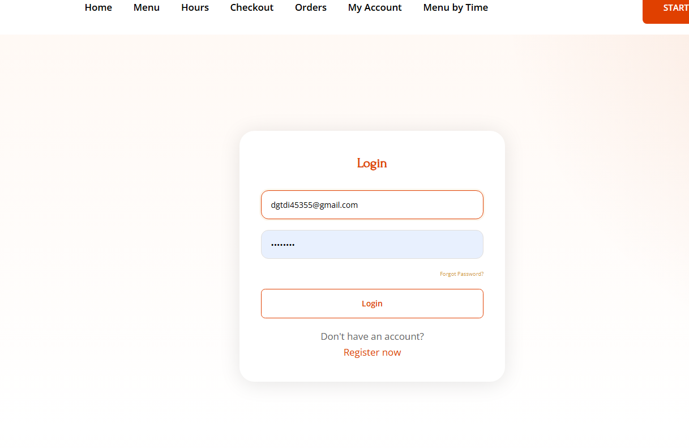

[Figure 3: Login page using session-based authentication, with a "Forgot Password" link]
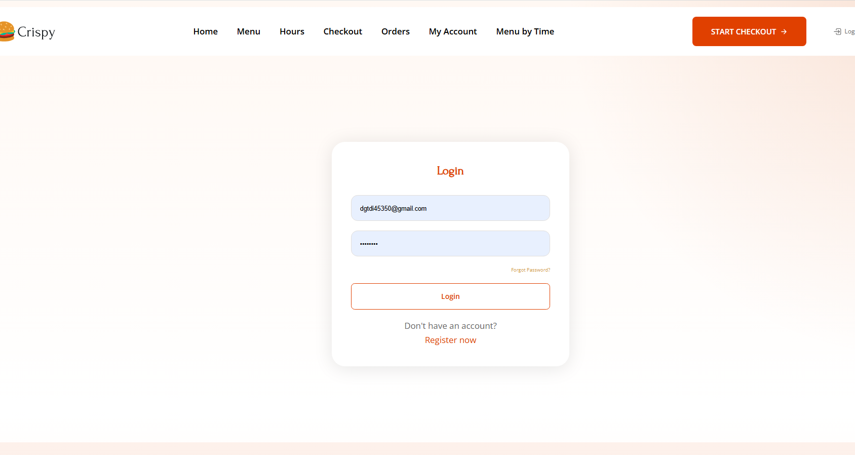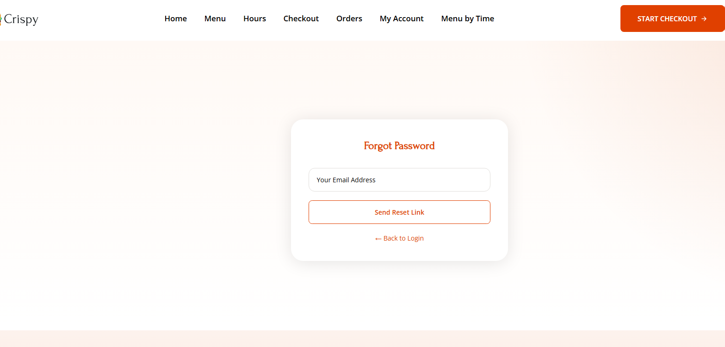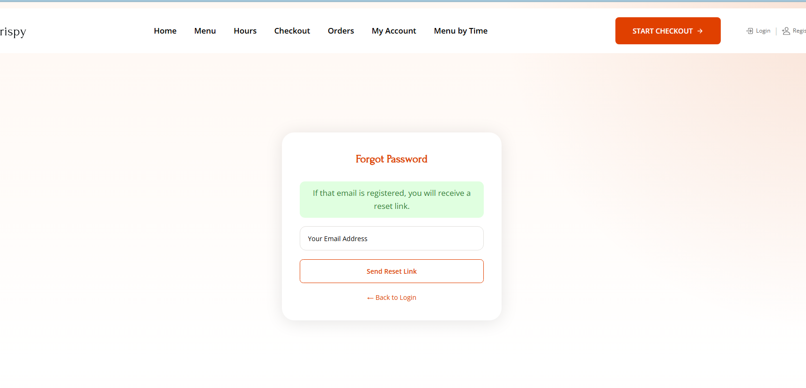
[Figure 4: Homepage (index.php) showing three random meal recommendations based on the current time period]
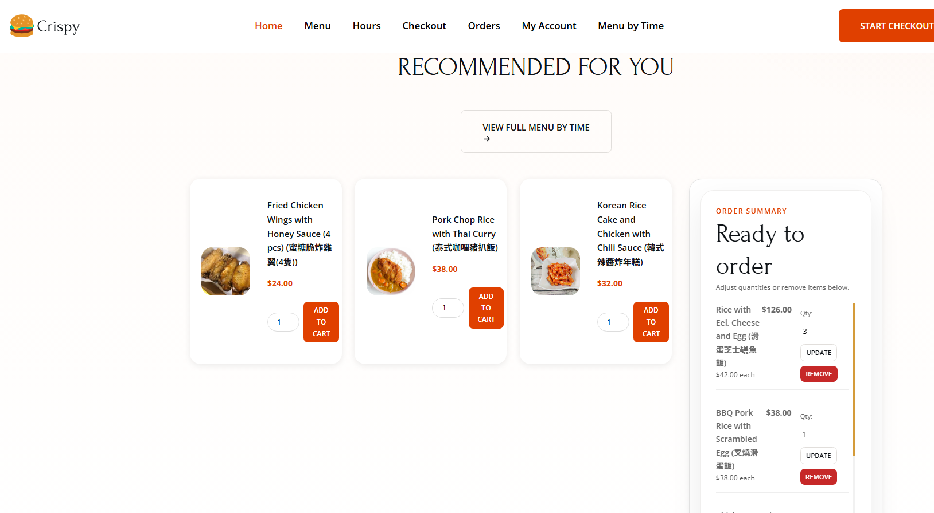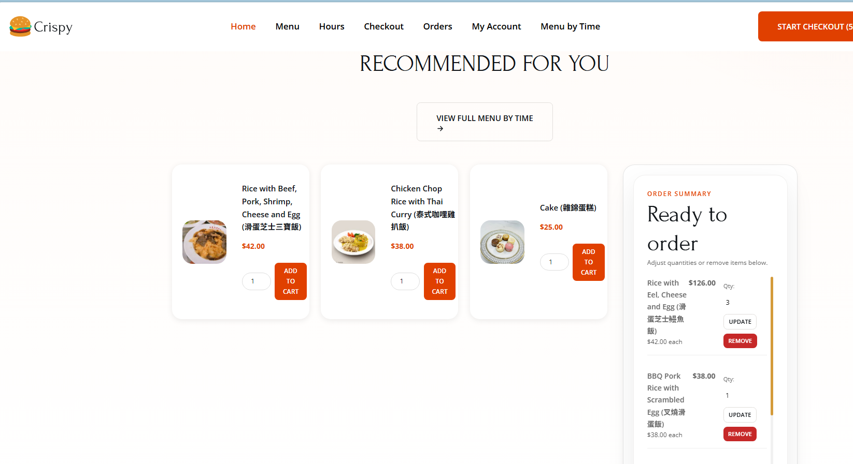

[Figure 5: Menu browsing by time period – includes Breakfast/Lunch/Dinner tabs, category filter, and keyword search]
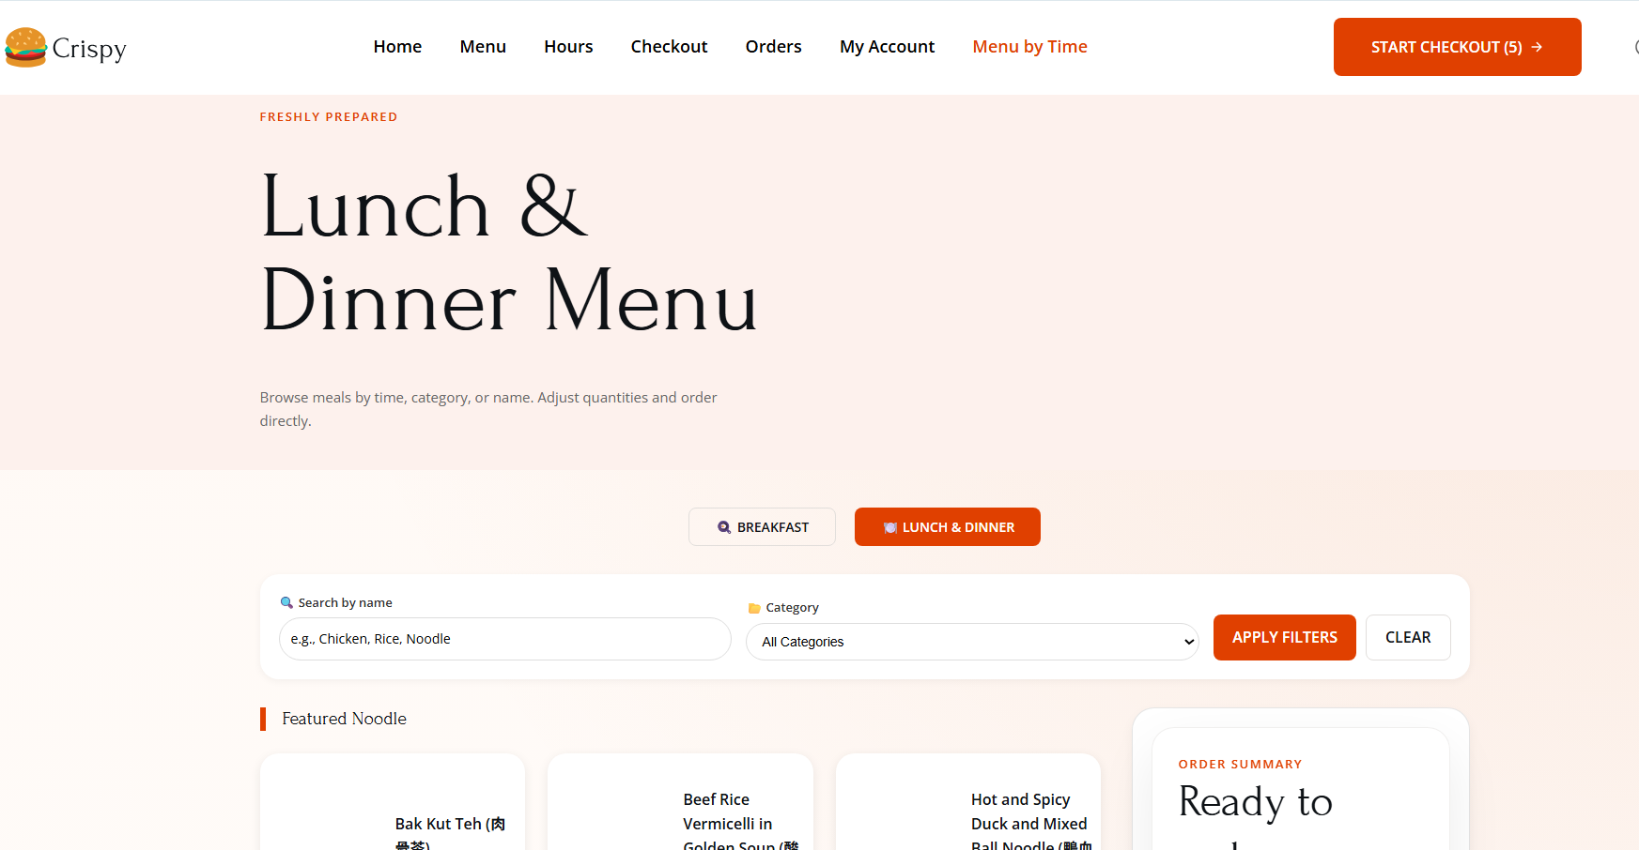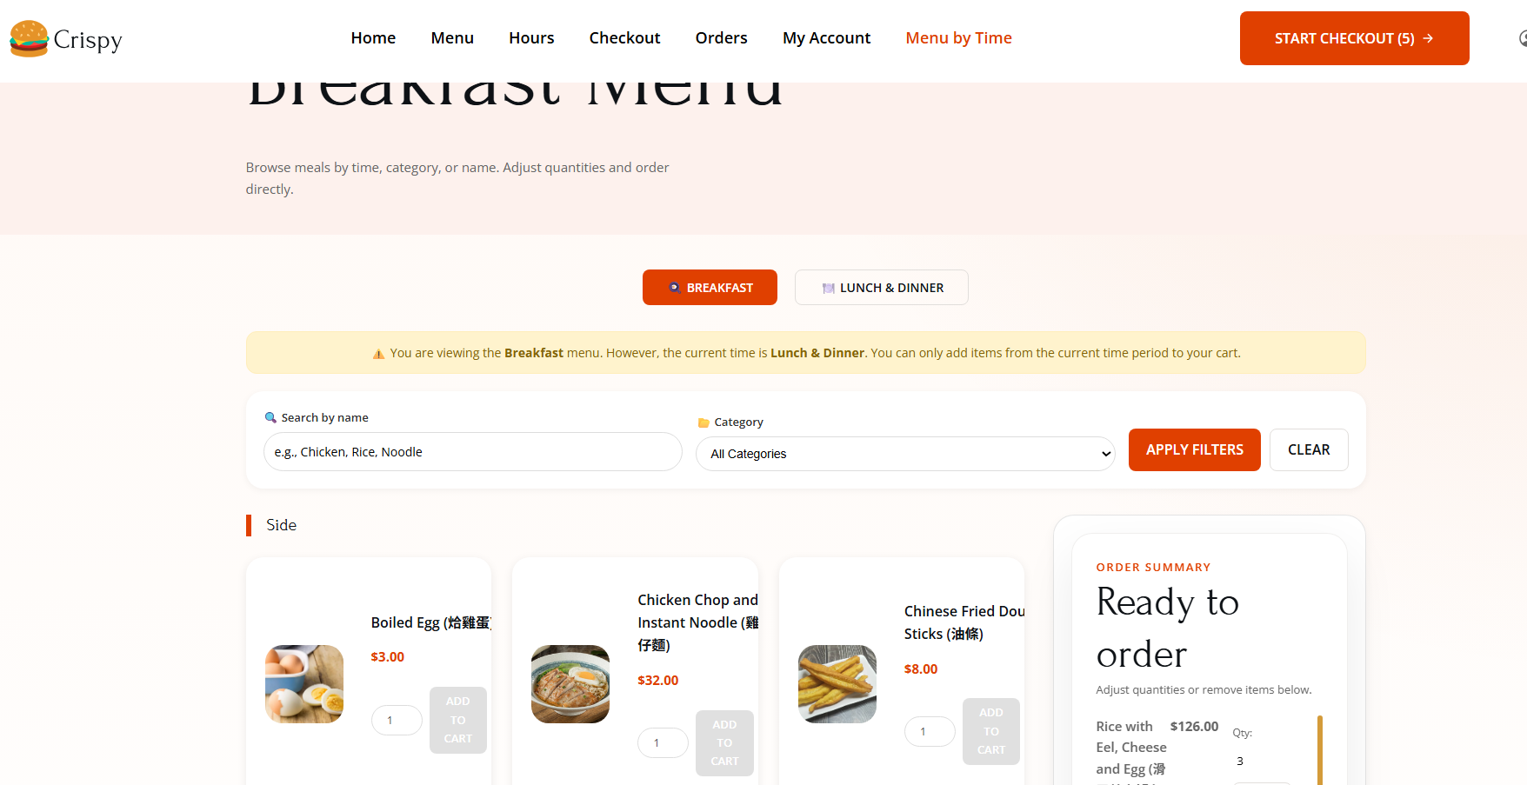
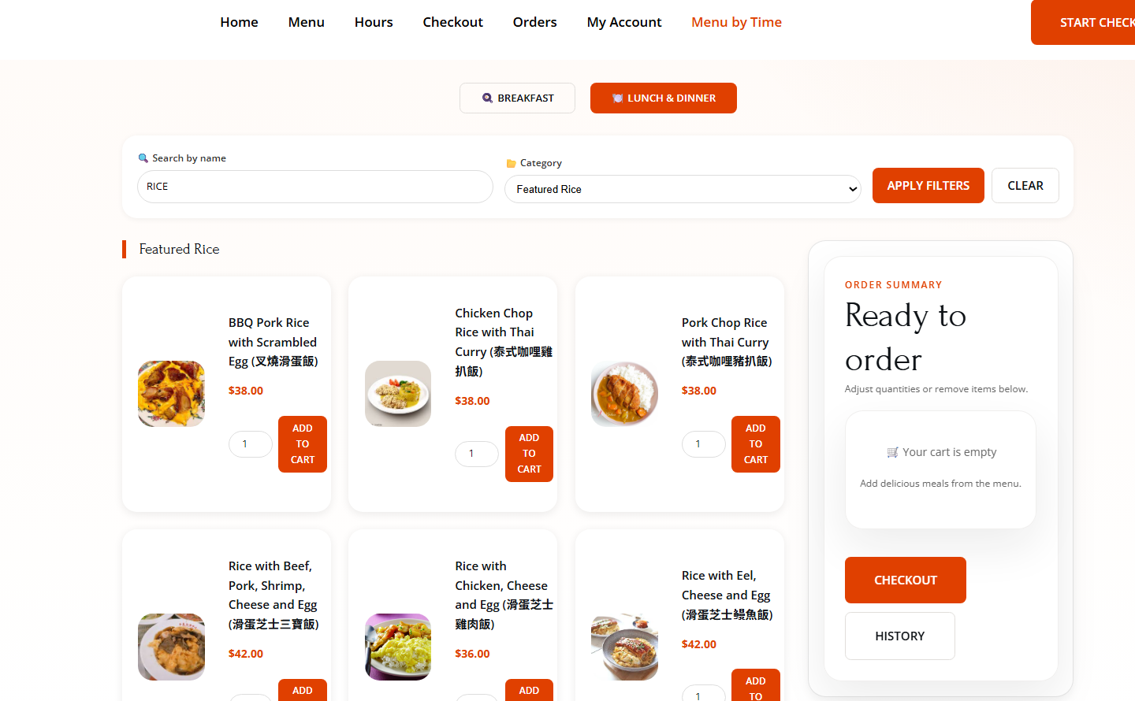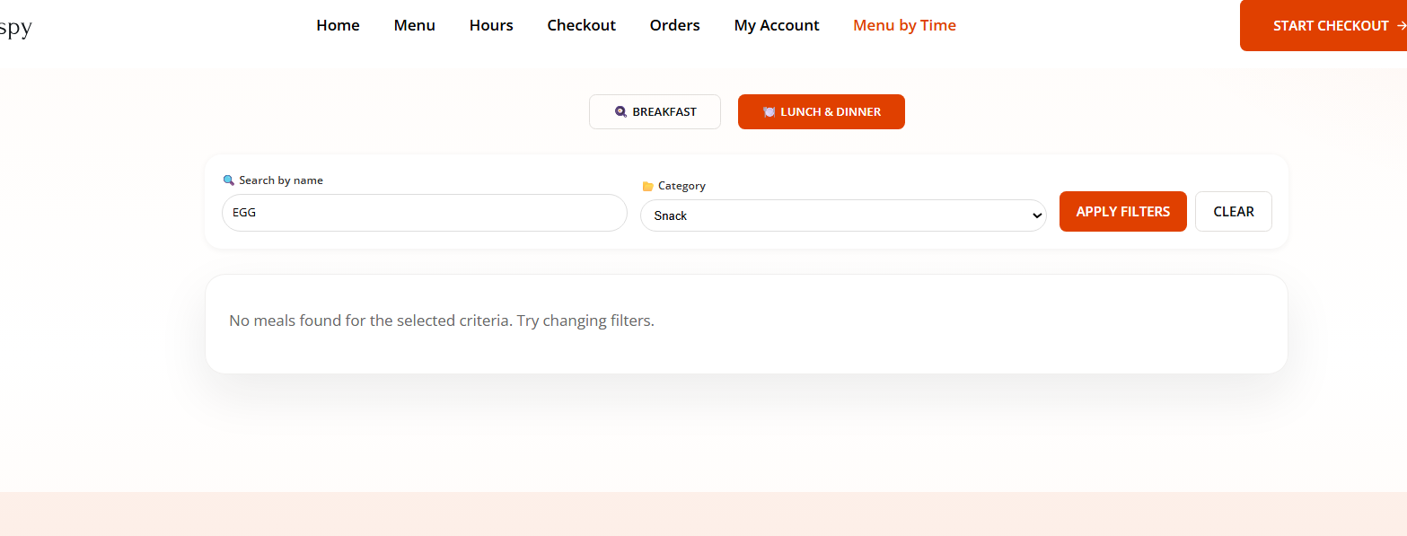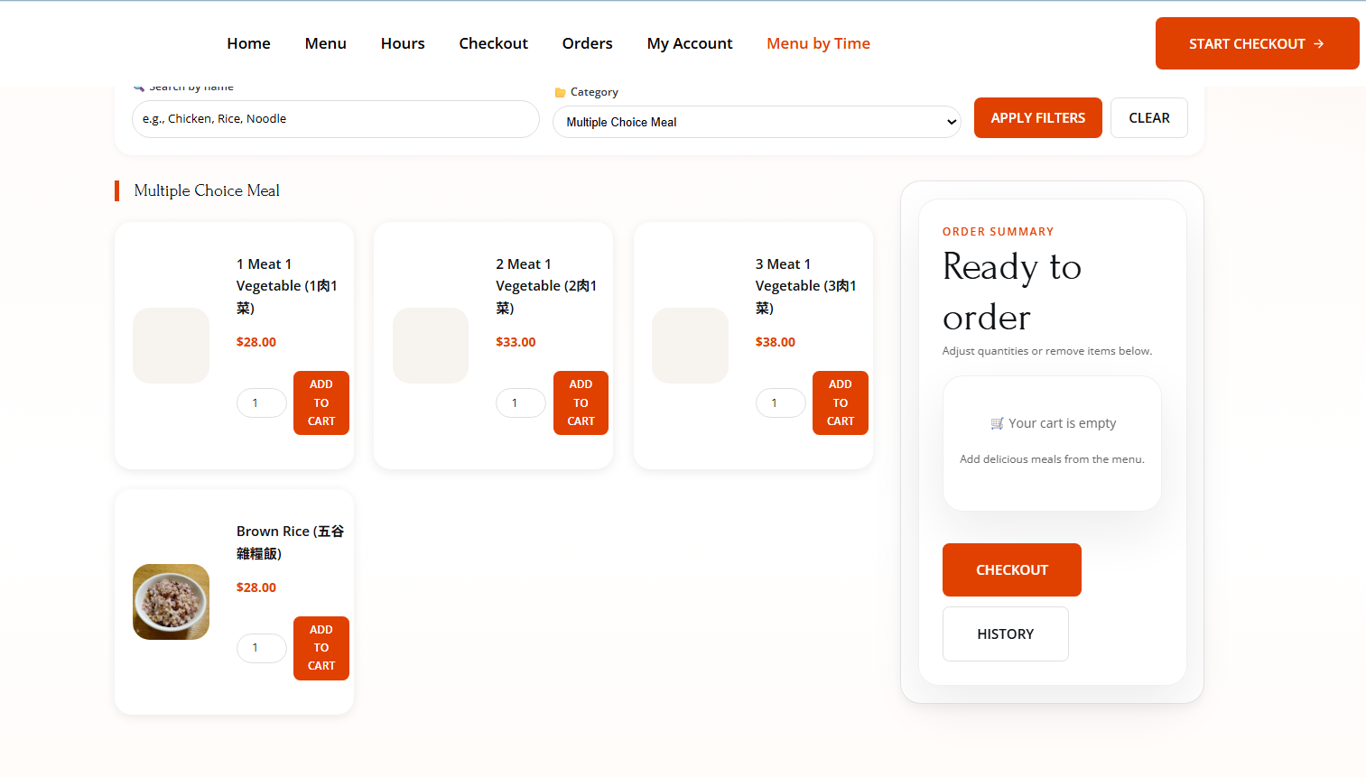

[Figure 6: Shopping cart sidebar supporting AJAX quantity updates, remove buttons, and real-time total price calculation]
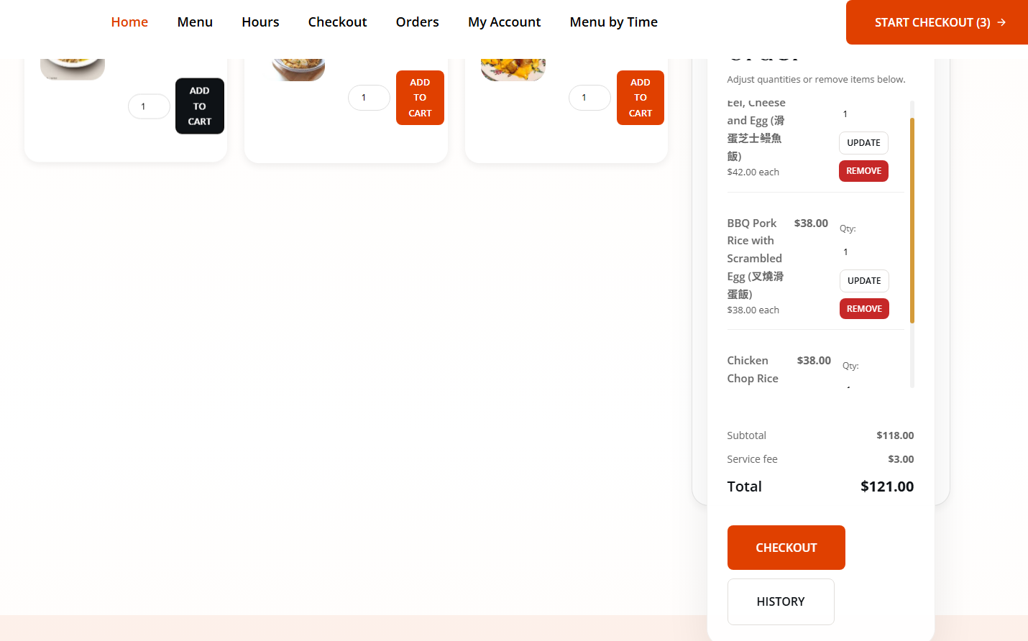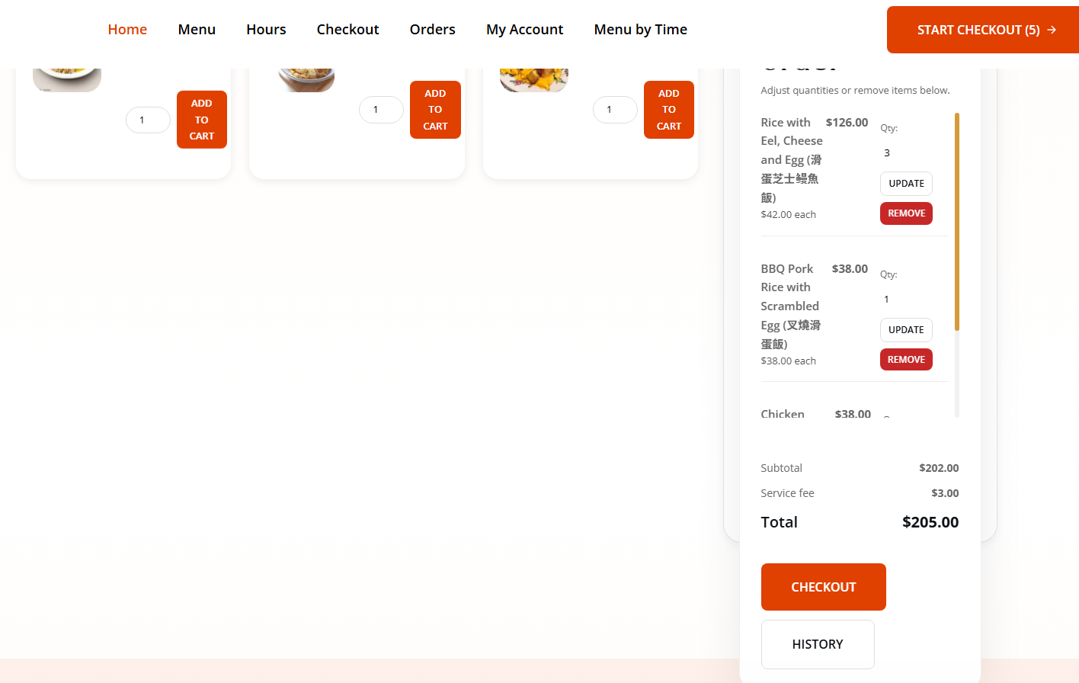
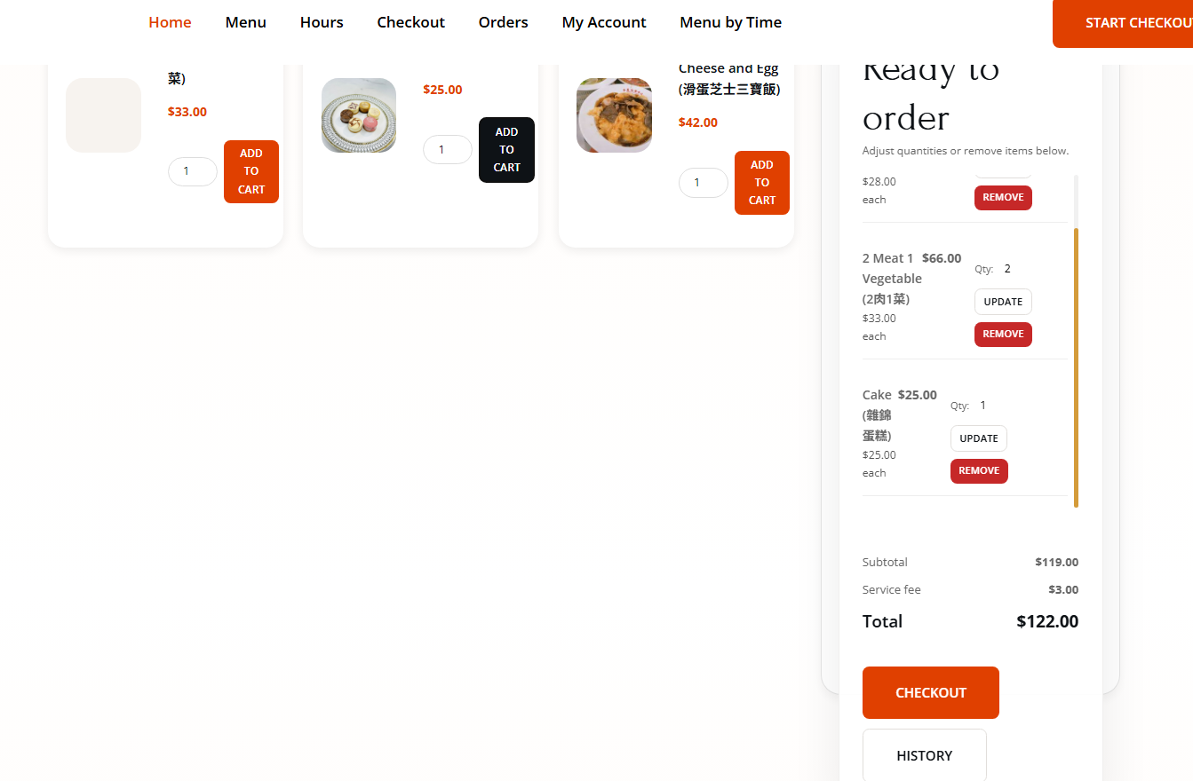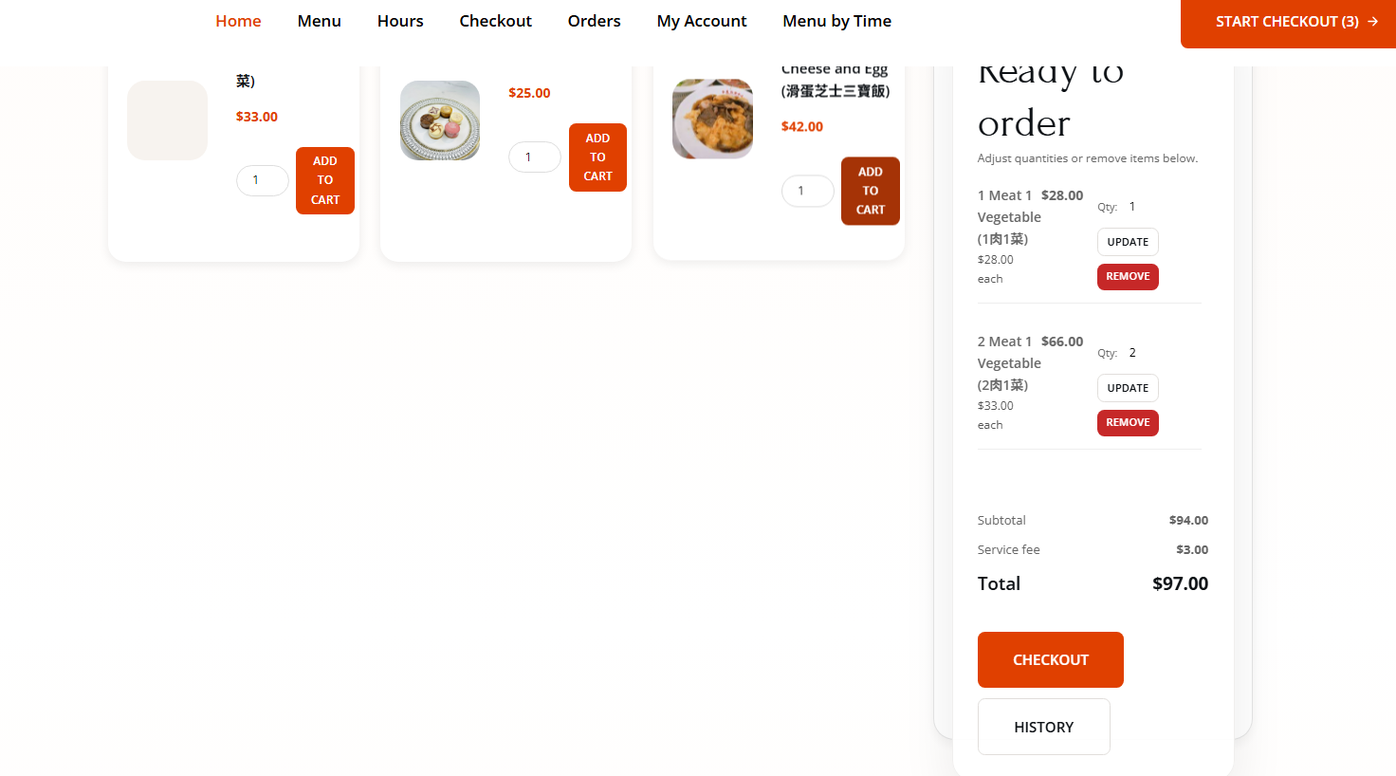

[Figure 7: Checkout page with pre-filled user information, pickup date picker, and dynamic slot filtering based on meal availability]
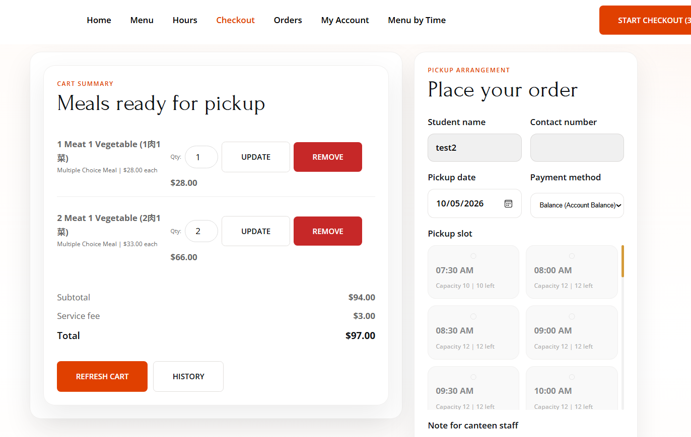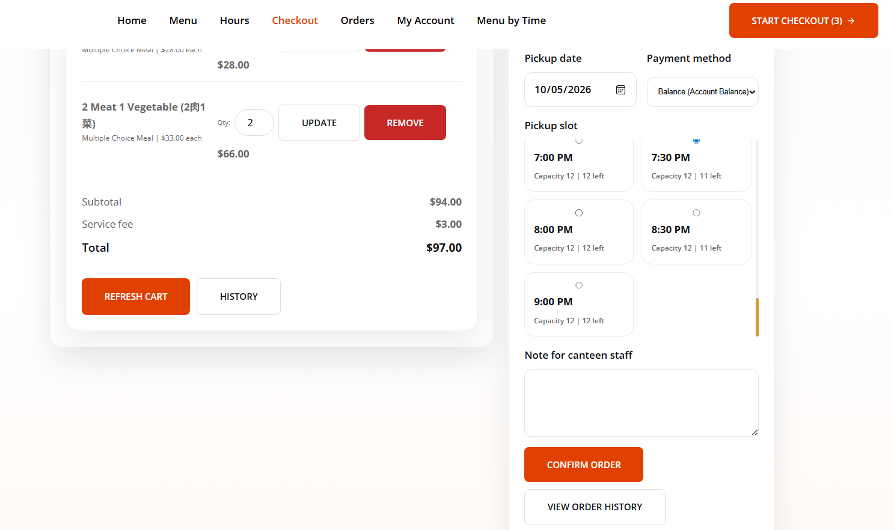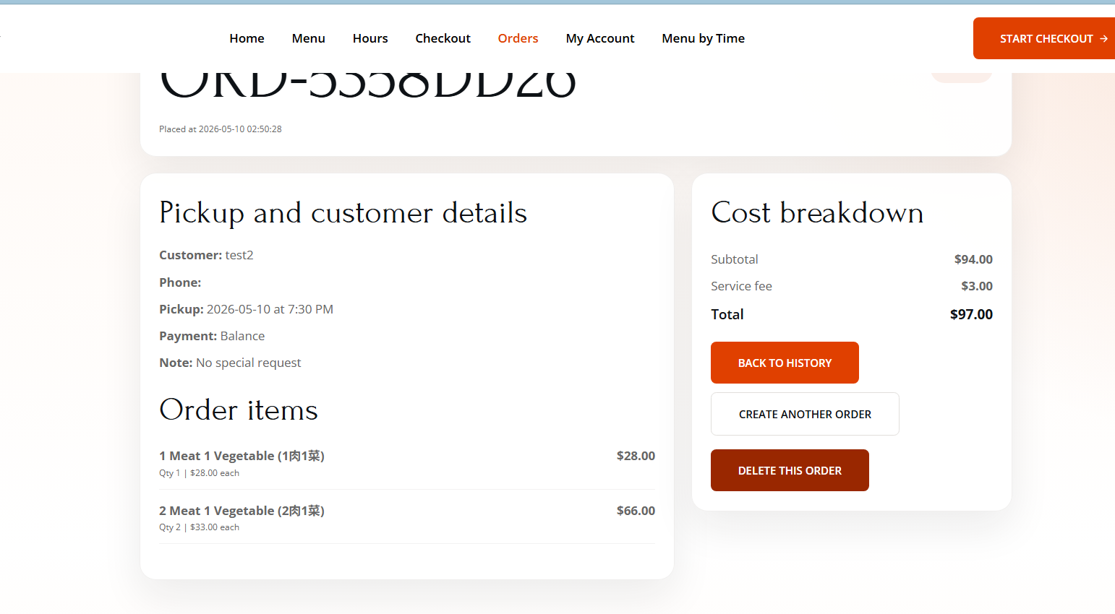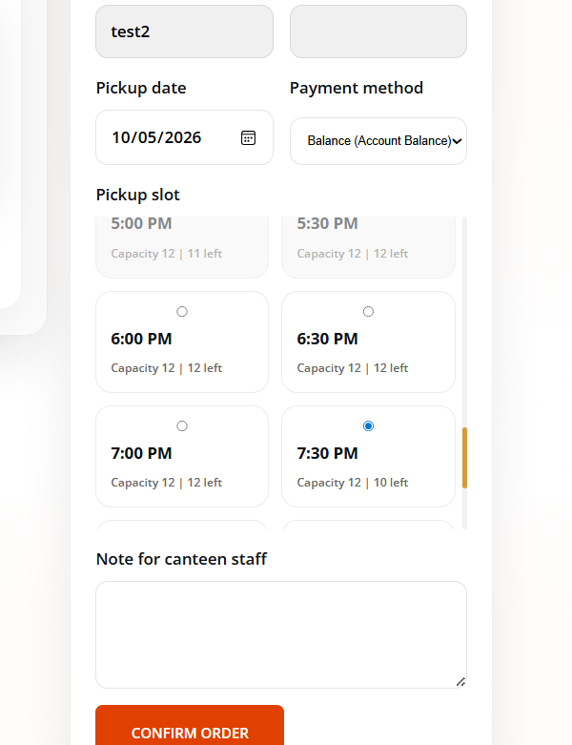

[Figure 8: Order history page listing all user orders, with search and delete options]

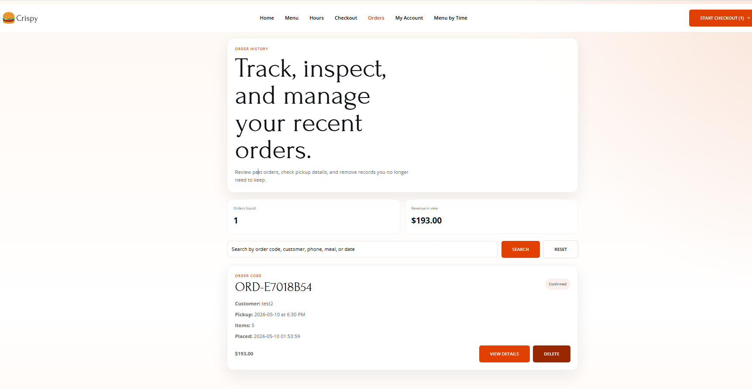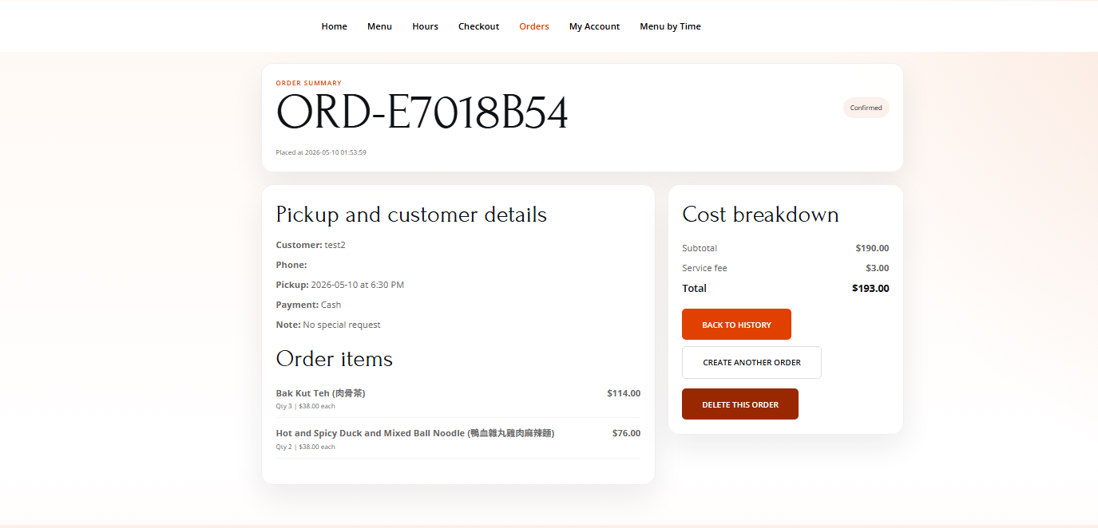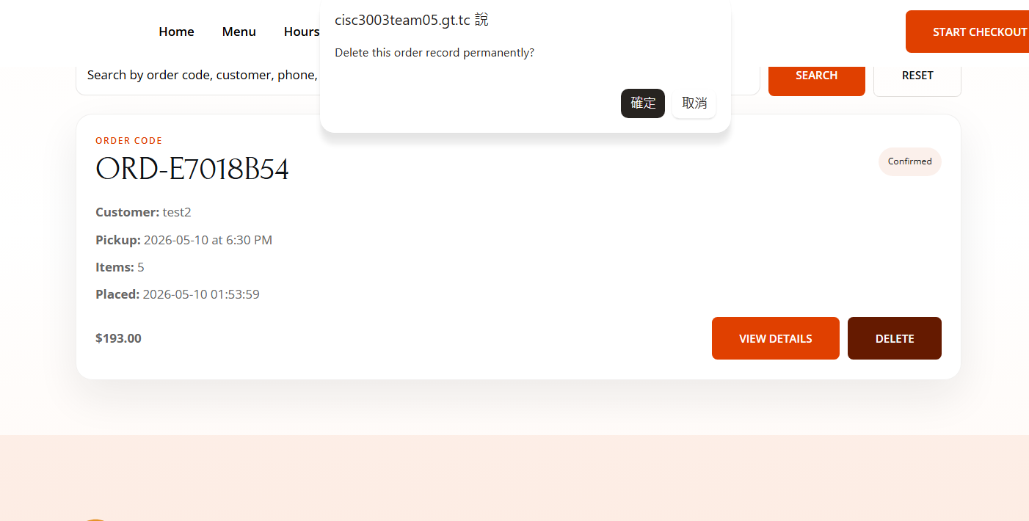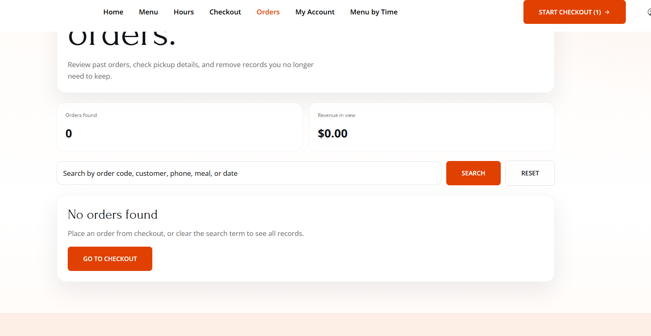
[Figure 9: Account dashboard (account.php) showing profile information, balance top-up, password change, and recent orders]
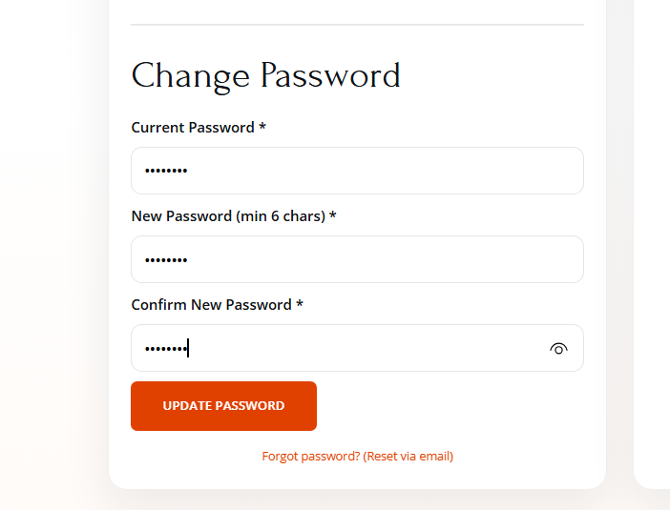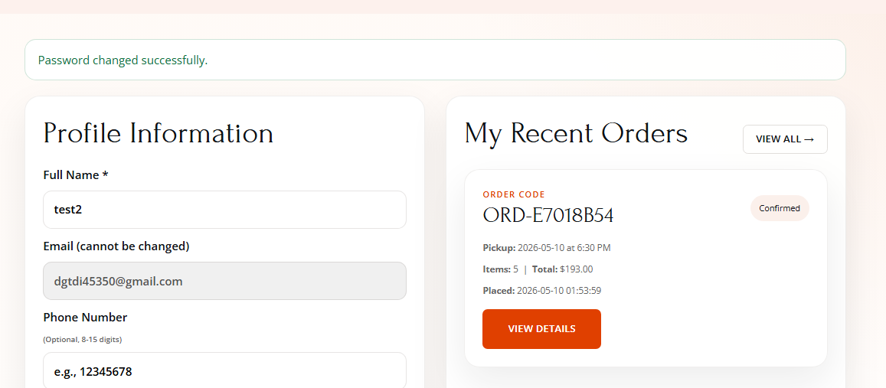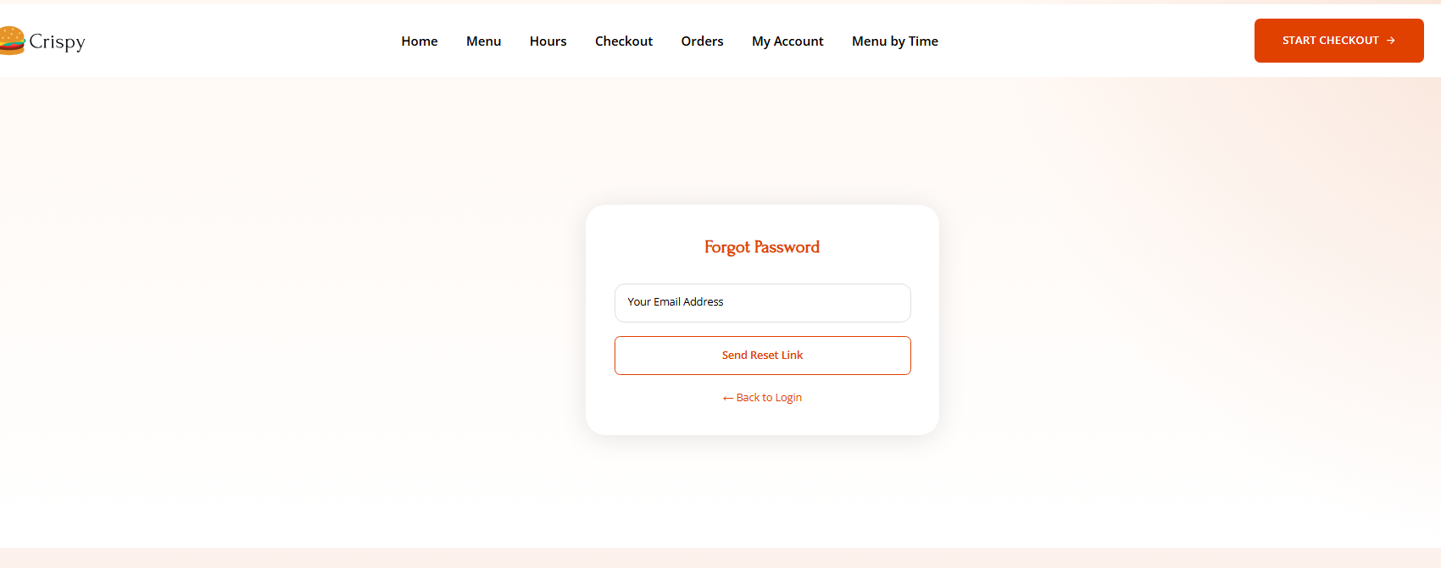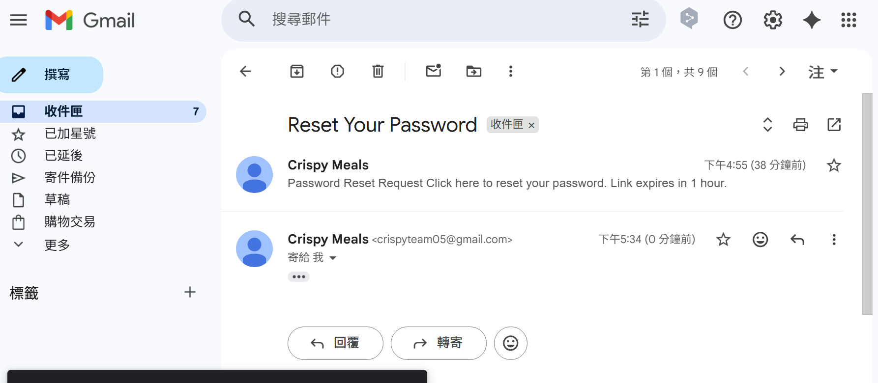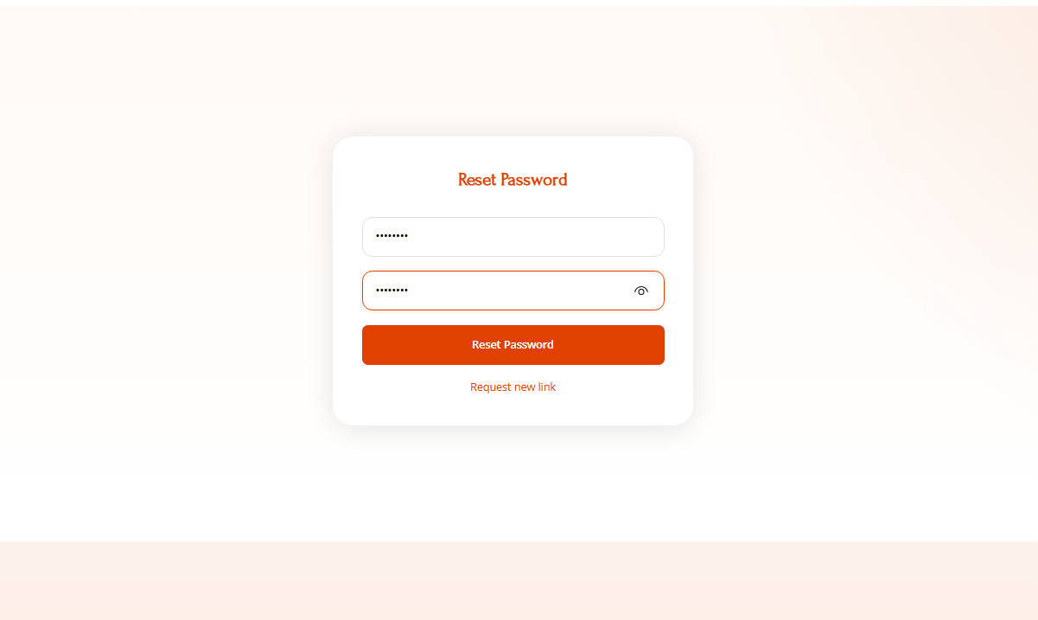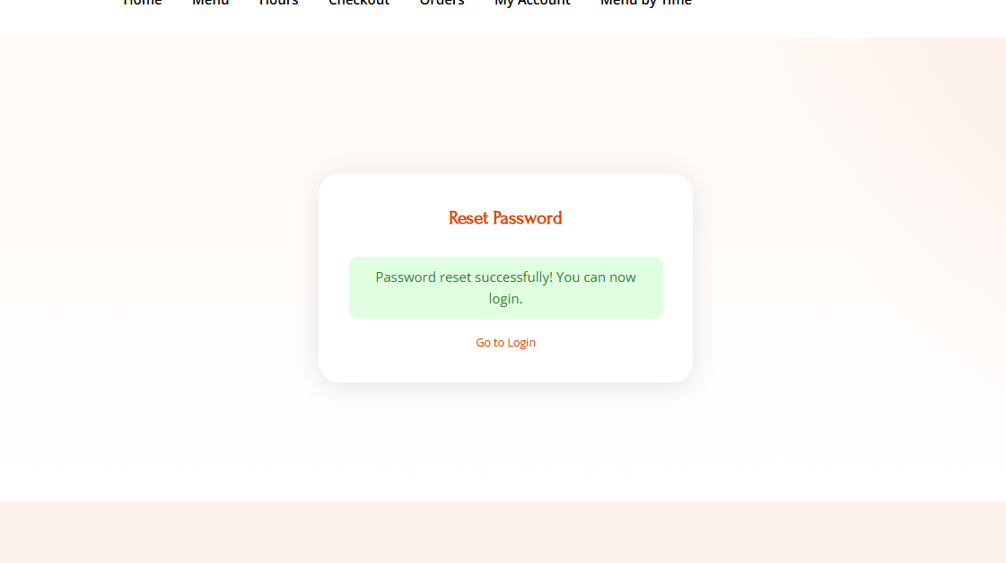
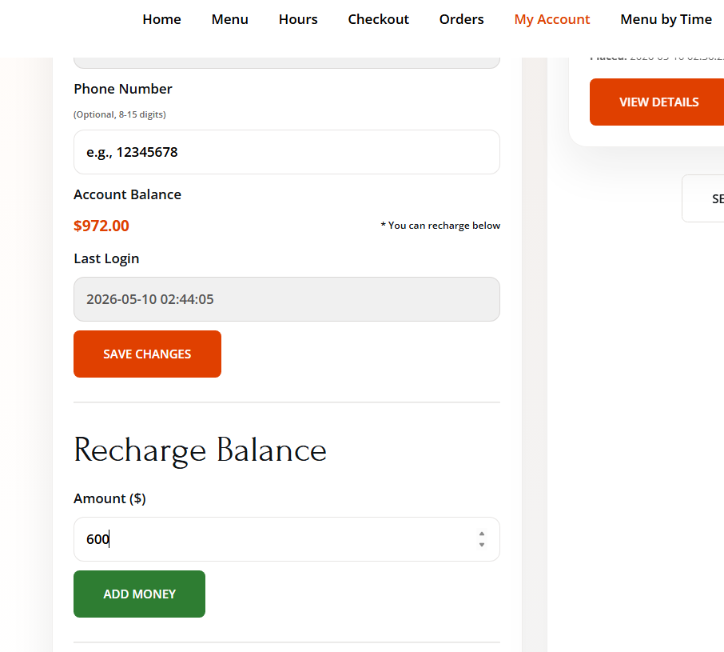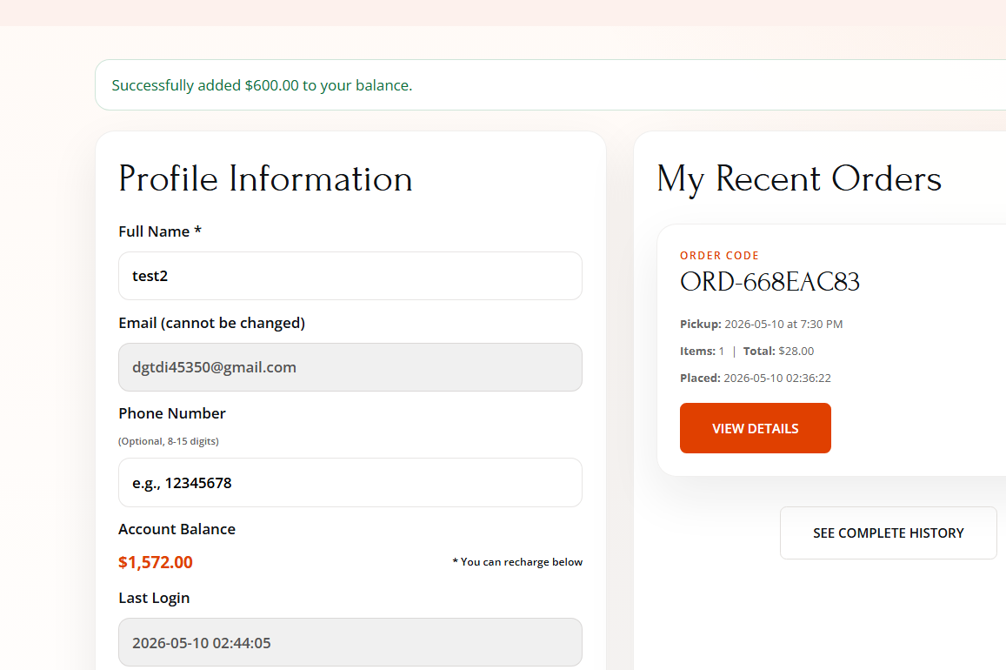
[Figure 10: Mobile responsive design – menu page view with collapsible navigation and stacked layout]
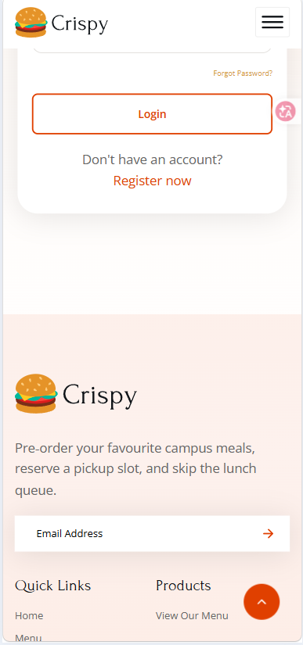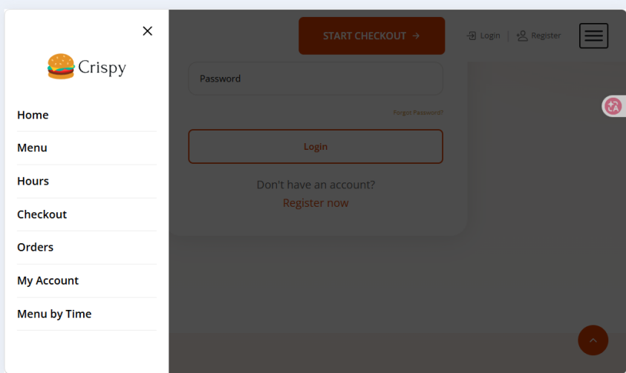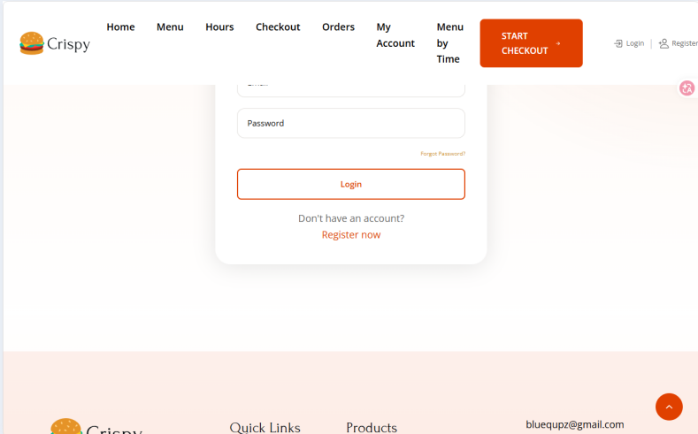

15.Project Declaration of AI Usage
We used ChatGPT as a coding assistant for generating boilerplate PHP/JS code, debugging session. All AI-generated content was manually reviewed, tested, and modified by team members to ensure correctness, security, and alignment with project requirements. No AI was used to bypass core learning outcomes.

16.Project Related References
Video Tutorials:
codewithsadee. (2023, Jan 4). How to Build A Delicious Fast Food Website Using HTML CSS JavaScript [Video]. YouTube. https://youtu.be/2F0PQEN1254?si=rVirJg7CSfw4xNm1
How to Become a Developer. (2023, Apr 1). Responsive Portfolio Website From Scratch [Video]. YouTube. https://youtu.be/ldwlOzRvYOU?si=fAhdQIZaniTvcZCn

Online Resources:
Coder Coder. (2018, Apr 24). How to layout and design a website (without any design skills!). https://coder-coder.com/layout-design-website/
Coder Coder. (2018, Sep 21). Build a responsive website layout with flexbox (Step-by-step guide). https://coder-coder.com/build-flexbox-website-layout/
Duckett, J. (2014). HTML and CSS: Design and Build Websites. John Wiley & Sons.
Fielding, R. T., & Taylor, R. N. (2002). Principled design of the modern Web architecture. ACM Transactions on Internet Technology (TOIT), 2(2), 115-150.
MySQL Official Documentation. https://dev.mysql.com/doc/
PHP Manual. (2026). PHP: Hypertext Preprocessor. https://www.php.net/manual/en/
PHP: PDO – Prepared Statements. https://www.php.net/manual/en/pdo.prepared-statements.php
PHPMailer Documentation. https://github.com/PHPMailer/PHPMailer

Validation Tools:
Central Coffee. (2018). Bespoke organically-sourced coffee. https://thecodercoder.github.io/central-coffee-demo/
MySQL Query Validator (for PHP‑executed queries): https://www.mysqltutorial.org/mysql-check-query/
PHP.net – Error Handling and Logging: https://www.php.net/manual/en/book.errorfunc.php
ui.dev. (2024). Am I Responsive? https://ui.dev/amiresponsive
W3C. (2024). Markup Validation Service. https://validator.w3.org
W3Schools – How to Host a Static Website (PHP hosting basics): https://www.w3schools.com/howto/howto_website_host_staticwebsite.asp
W3schools. (2026). How To Host a Static Website. https://www.w3schools.com/howto/howto_website_host_staticwebsite.asp

